Apresentação do nosso projeto: feedbacker
https://feedback.fish/
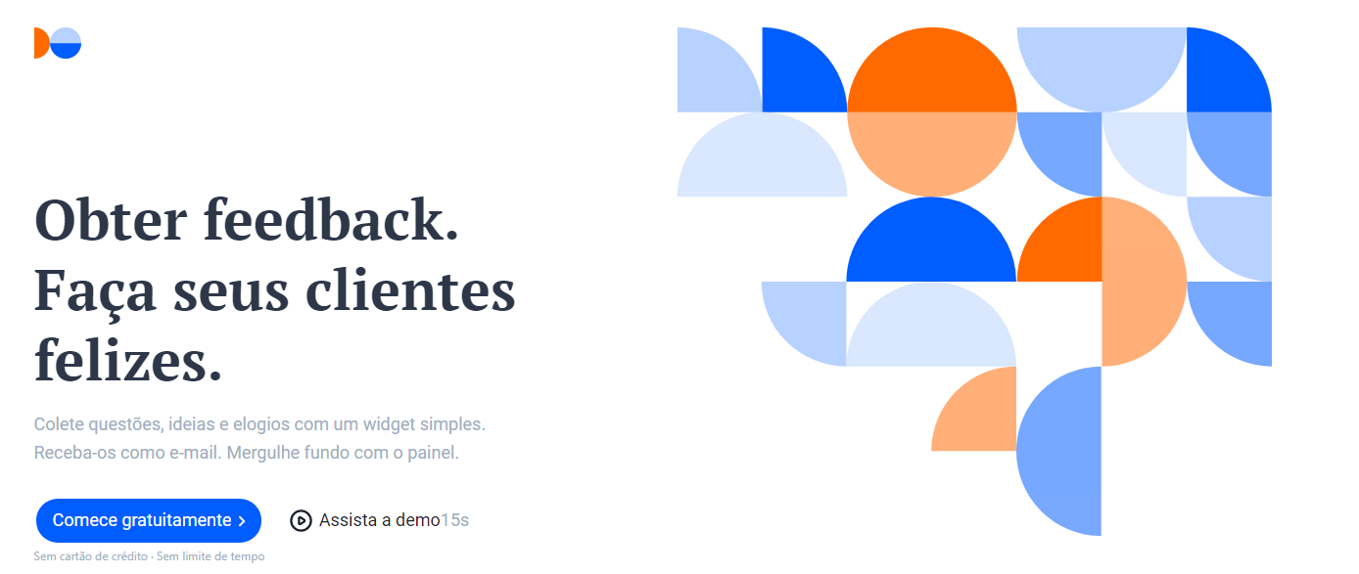

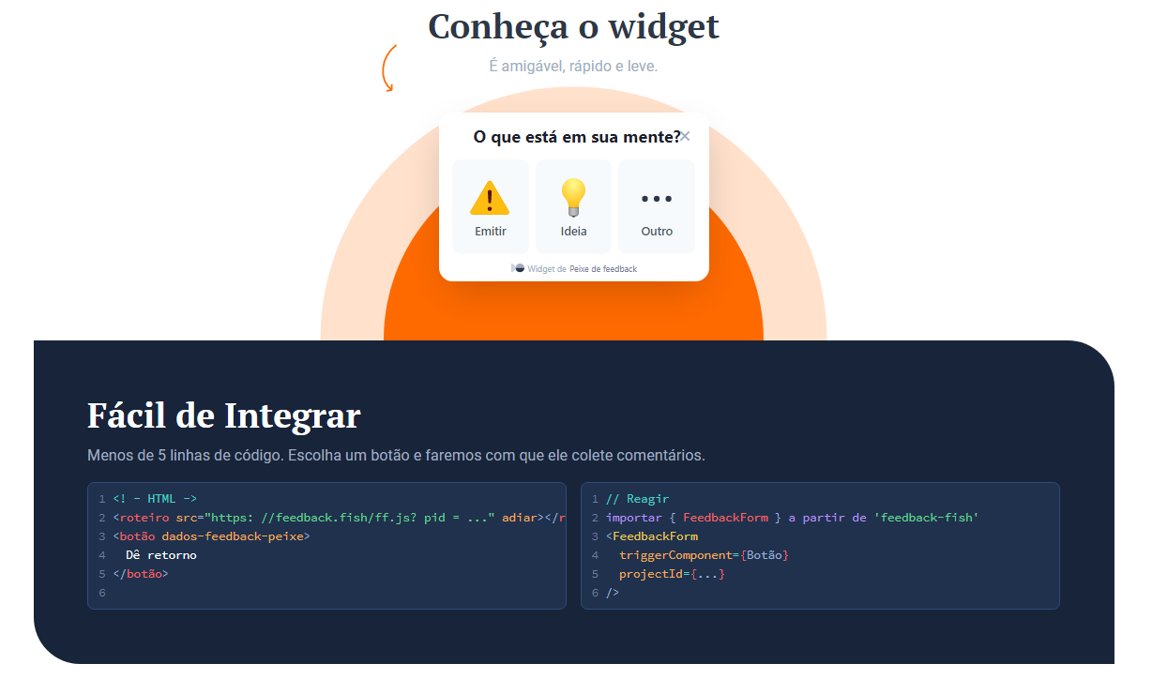

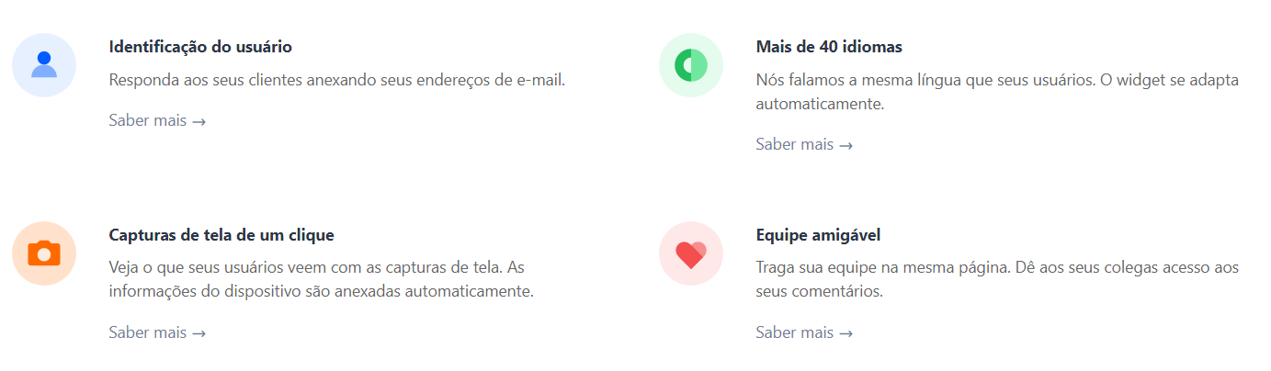
Colocar um botão e um Script no Site e ele monte um widget
https://www.youtube.com/watch?v=VzT2Thd0asc&list=TLGGw49Jn9vWVfozMDA1MjAyMQ&t=1s&ab_channel=MaxStoiber

https://www.figma.com/file/WhUZBnYnxgXVImQjh04Qon/Admin?node-id=0%3A1
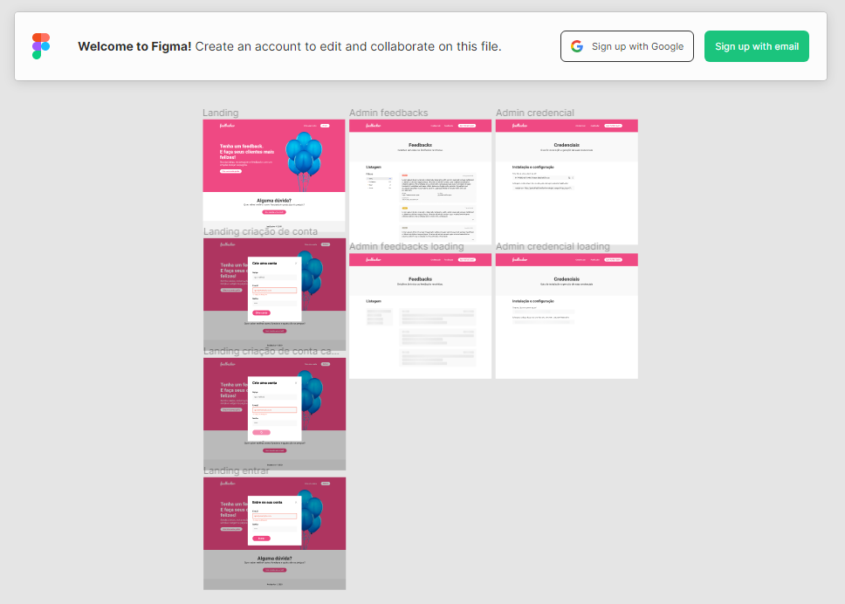

https://www.figma.com/file/VYWmc92nrhSqrgUxf6QpFj/Widget
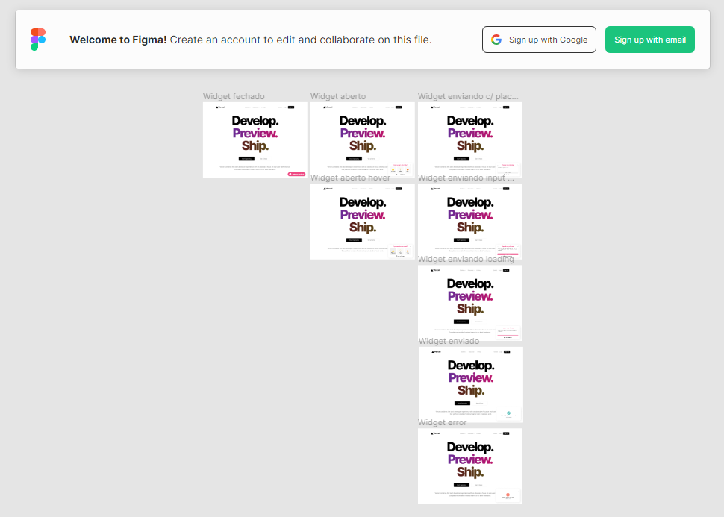

Links citados na aula
- Link do discord pra responder dúvidas: https://discord.com/invite/jD7g8eKKmz
- Figma do Dashboard: https://www.figma.com/file/WhUZBnYnxgXVImQjh04Qon/Admin?node-id=0%3A1
- Figma do Widget: https://www.figma.com/file/VYWmc92nrhSqrgUxf6QpFj/Widget?node-id=0%3A1
- Plataforma que eu disse: https://feedback.fish/
- Código fonte do curso: https://github.com/vuejs-br/treinamento-vue3-code/

